**STABILITY LOG FOR R1803**

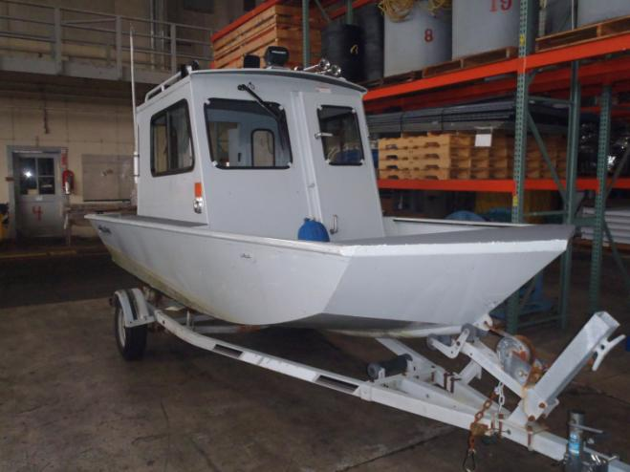

As Delivered Specifications:

Type: Utility Boat

Manufacturer: Sea Ark Marine Inc.

Model: 1860 River Runner SAMA 2005/010

Length: 18 feet, Beam: 7 feet

Engine: 2010 Yamaha, 115 HP 4-stroke, 402 lbs

Freeboards as delivered at sea trials:

* Bow: 27 inches
* Port AFT: 15 inches
* STBD AFT: 12 ½ inches
* Draft Hull: 12 ½ inches (6 inches with engine tilted clear of water)

Boat Weight (dry): 1780 lbs.

Fuel Tank (portable): 12 gals. (72 lbs.)

Electrical: Single battery, 12 VDC Power Electrical System, 120 VAC Shore-power with automatic battery charger.

Bilge Pump: 3700 GPH bilge pump with automatic float switch located AFT below outboard engine motor well, discharging on STBD side.

Manufacturers placarded carrying capacity with motor, persons, and gear: 2018 lbs

Gear and personnel only carrying capacity: 1616 lbs

Date Modification Weight added/Deleted Capacity Notes

|  |  |  |  |  |
| --- | --- | --- | --- | --- |
| 10/25/11 | Vessel delivered new | 0 | 1616 lbs |  |
| 11/08/11 | Added second 12VDC battery | +31 lbs | 1585 lbs | Updated SBOM |
| 01/15/12 | Added radar | + 22 lbs | 1563 lbs | Updated SBOM |
| 6/01/12 | Weighed boat | 0 lbs | 1563 lbs | No change |
|  |  |  |  |  |
|  |  |  |  |  |
|  |  |  |  |  |